TMT/ INDHAN GREEN ENERGIES/S0567/2025 24-11-2025

To,
INDHAN GREEN ENERGIES
Email: Indhangreenenergies@zohomail.in
Address: Bramilli compound street,
West Godavari Dist, Andhra Pradesh-534275
GSTIN: 37AAKFI5458E1Z5

Dear Sir,

SUB :- SUPPLY Bailing press

We thank you for your inquiry regarding scrap Bailing press with capacity 100TPD.
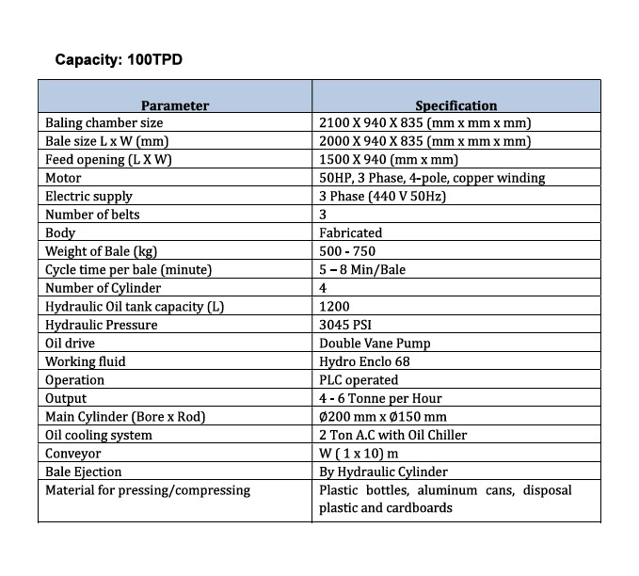

The price details of the machine are Rs 24,00,000(Twenty-Four Lakhs only).

GENERAL TERMS & CONDITIONS:

1. Price quoted per unit ex-work. Hyderabad.
- Following charges are additional to your account.
- Freight Charge : As actual to be borne by you.
- Sales Tax : 18% GST
- Packing charge : As actual to be borne by you.
- Insurance : As actual to be borne by you.
- Payment : 75% advance along with order balance before delivery but after inspection at our works.
- Delivery : with 75% advance 1month / With 50% advance 2 months / With 30% - 4 months from date of advance received
- Validity : One month from the date of submission.
- Inspection : Inspection at our works prior to dispatch.
- Warranty : The machine is warranted for a period of 12 months from the date of dispatch against any manufacturing defects/ faulty material or bad workmanship of any part or component but not against any kind of abnormal or improper use of machine. Defective part or component will be replaced or repaired free of cost. Electrical components are outside the scope of this warranty.
- Commissioning : Erection & commissioning done by you, but required technical support & guidance provide by us at additional cost.
NOTE:
- Oil is not in scope of our supply.
- Raw material for trial is to be arranged by you at your cost.

We are sure you will find our offer in line with your requirements. Should you require any further clarification please contact 9246221106
Thanking you and assuring you of our best services.

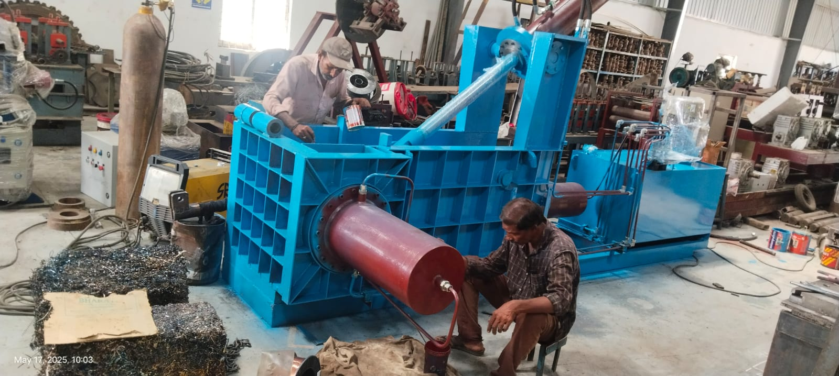

For TECHNO MACHINE TOOLS

(T.SIVARAMAKRISHNA)

